**DBMS Laboratory**

**UE19CS304**

**5th Semester, Academic Year 2021-22**

Week #: 7 - Set Theory Operations Date: 23/10/2021

|  |  |  |
| --- | --- | --- |
| Name :  SUMUKH RAJU BHAT | SRN :  PES1UG19CS519 | Section :  H |

1. Make a list of all project numbers for projects that involve an employee whose last name is ‘Smith’, either as a worker or as a manager of the department that controls the project.

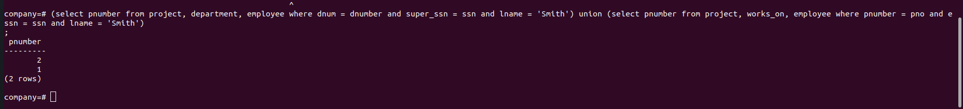

1. Retrieve the names of the employee who does not have dependents.

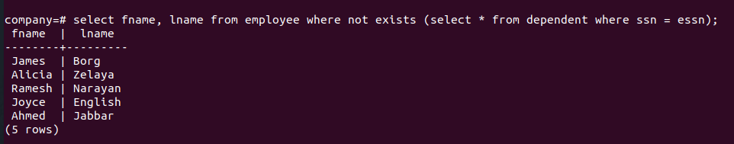

1. Retrieve the Social Security numbers of all employees who either work in department 5 or directly supervise an employee who works in department 5.

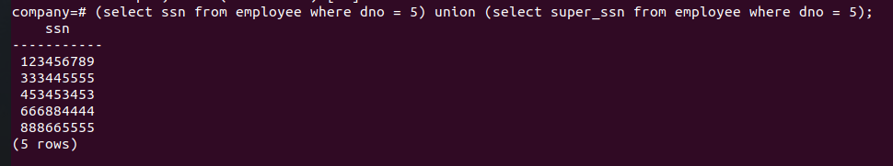

1. Using Intersect find all projects controlled by the department 5 and has employee ssn 123456789 working in that project.



1. Using Except find all ssn of employees who works in department 5 but not in Bellaire location

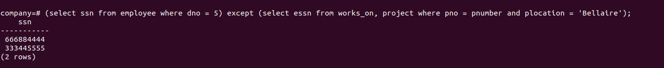

1. Find the name of the employee who has the same name as the dependent of any employee 